KLE Dr.M.S.Sheshgiri

College of Engineering & Technology

Udyambag, Belgaum – 590008

Branch

**“CS”**

Project

**“RESTAURANT BILLING SOFTWARE”**

Presented By

Anish Bhandarkar

**Introduction**

The project “RESTAURANT MANAGEMENT SYSTEM” is implemented to reduce the manual work and enhances the accuracy of work in a restaurant. It is a desktop application to restaurant management. So, the project is designed proficiently to help restaurants.

This system ensures to provides service facility to restaurants and owners automate their BILLING OPERATIONS.

This system entirely reduces the unnecessary wastage of time inside the hotel as well as it minimizes unnecessary calculations. This system is developed with inbuilt GST calculation in the bill, as well as it shows the amount in rupees how much GST is paid.

This project is fully developed in python language which is currently demanded in market using python GUI tkinter.

**Software requirements:**

1. OS: Windows 7 or higher
2. System type: 64 bit/32 bit OS

**Hardware requirements:**

1. RAM: 1.00GB
2. Disk space: >1GB
3. CPU: 2.30GHz

**Technology :**

Technology used - Python 3.8

* Python Tkinter GUI

Language used - Python

**Snapshots:**

GUI- Main display window

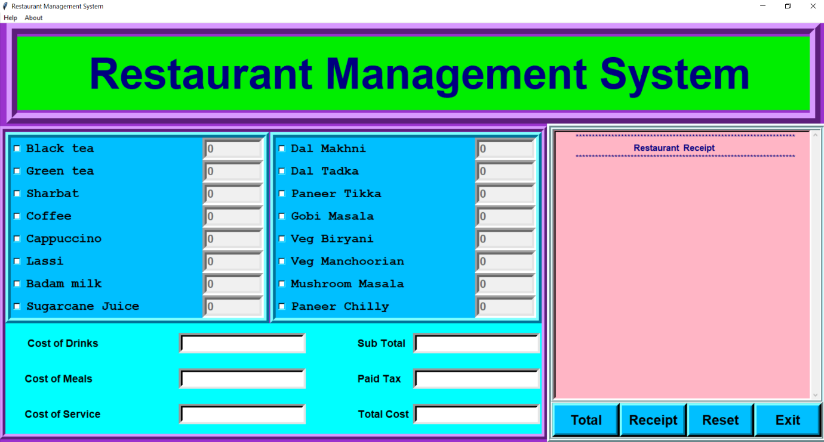

Help menu bar : Provides the overall functions applicable for system

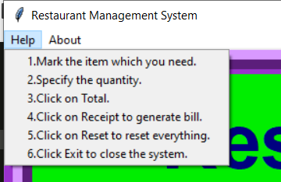

Buttons :



Total : This Button gives the calculation of the bill.

Receipt : It will display the receipt after calculation of total.

Reset : It will reset the window by clearing all values.

Exit : Exit from the system.

Selecting the items as per customers order :

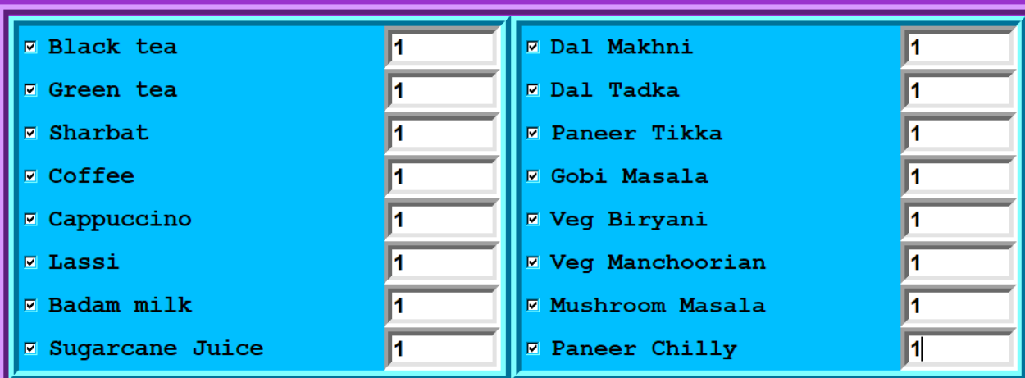

Click on Total button to calculate the overall cost

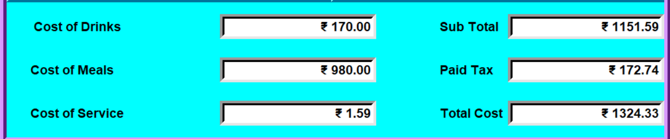

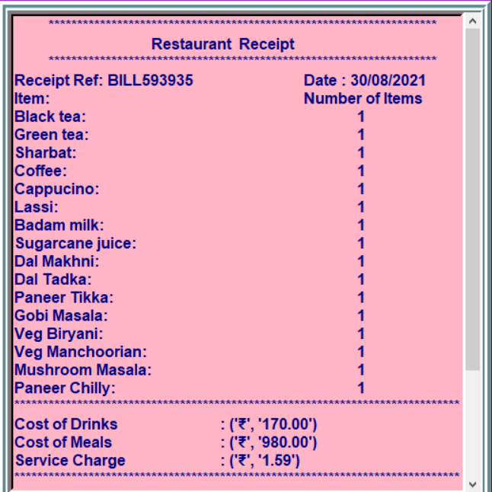Click on receipt button to generate receipt

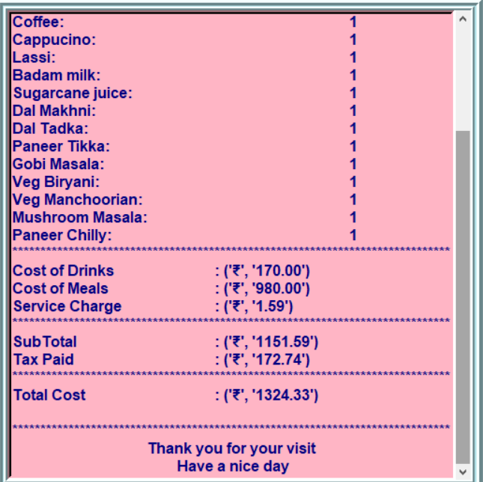

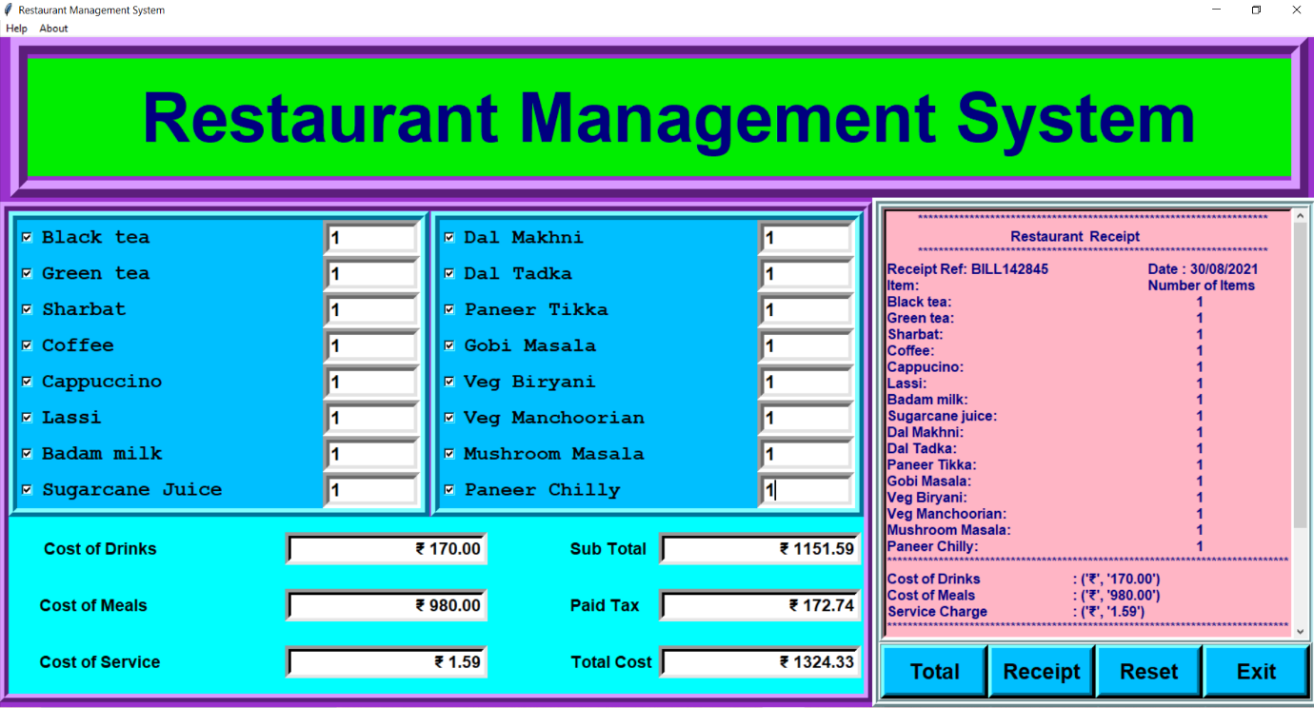Overall view after clicking Receipt button

For next entry, Click on Reset to clear everything, After clicking on Reset button

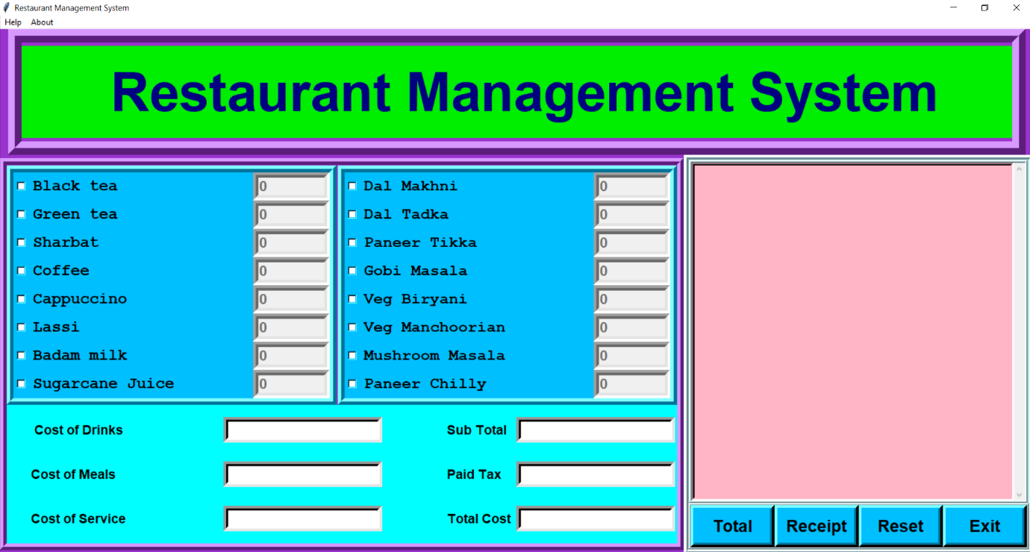

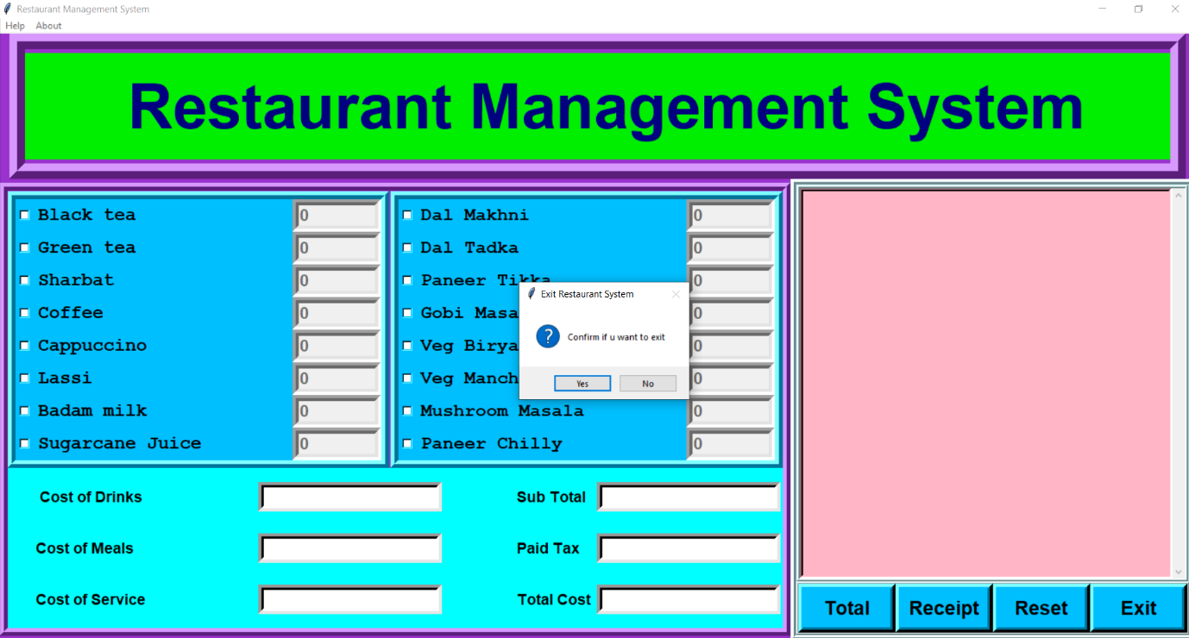To exit from the system Click on Exit button, and then click Yes

**Applications:**

-This system can be used in Restaurants

-It can also used in Hotels, Mess

**Conclusion:**

The outcome of all the time, hard work is here. We have a system which takes necessary choice of customers according to the category of the food available. This is achieved through an easy to use GUI menu options. According to the choice of customer a bill is generated.

For restaurant and hotel owners, this automized system helps them to minimize the workload and provides instant restaurant services to guests.

The fast growing use of digitalised systems confirms the good feature and scope of the proposed project.